V. S. University Soft Ball Men Team with Hon’ble Vice Chancellor Prof. G. M. Sundaravalli

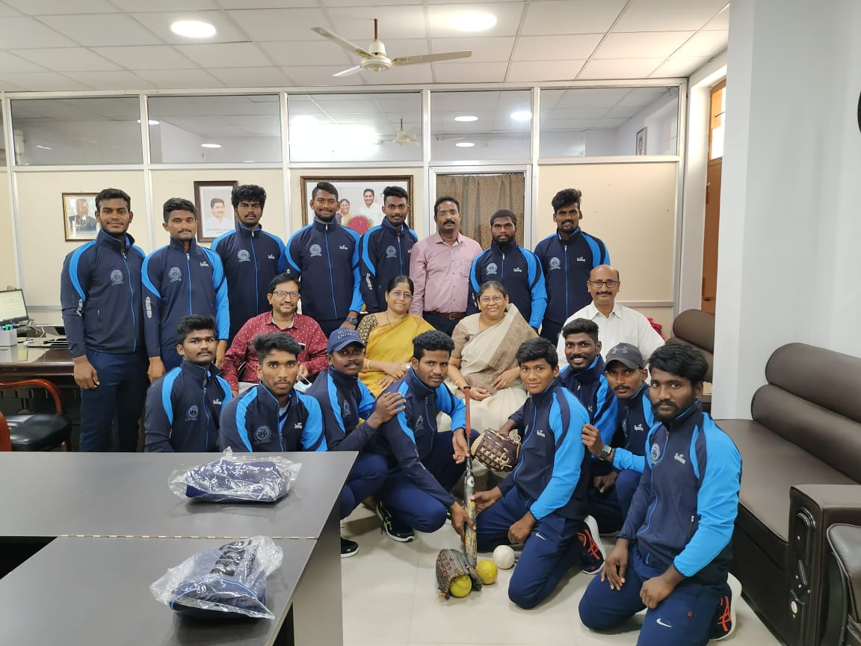
All India Inter University Soft Ball Men Tournament quarter finals match between
V. S. University, Nellore Vs Acharya Nagarjuna University, Guntur (2021-22)

